**PROJECT DEVELOPMENT PHASE**

**PRE-REQUISITES**

|  |  |
| --- | --- |
| DATE | 29 October 2022 |
| TEAM ID | PNT2022TMID28895 |
| PROJECT TITLE | Smart Lender - Applicant Credibility Prediction for Loan Approval |
| TEAM MEMBERS | |  |  | | --- | --- | | KOTHAI S | 411719104029 | | SHARMILA K | 411719104046 | | KALAIVANI L | 411719104021 | | ASHMITHA R | 411719104004 | |

**Smart Lender - Applicant Credibility Prediction for Loan Approval**

**PRE-REQUISITES**

To complete this project, you must require the following software, concepts, and packages

* Anaconda navigator:

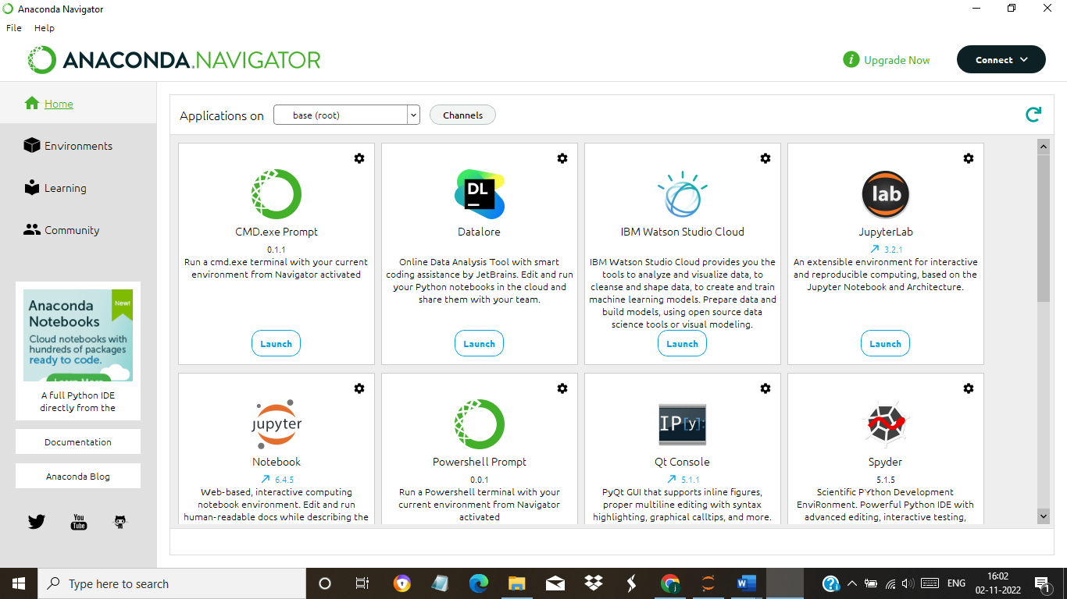

 Python packages:

Open anaconda prompt as administrator

* Type “pip install numpy” and click enter.
* Type “pip install pandas” and click enter.
* Type “pip install scikit-learn” and click enter.
* Type ”pip install matplotlib” and click enter.
* Type ”pip install pickle-mixin” and click enter.
* Type ”pip install seaborn” and click enter.
* Type “pip install Flask” and click enter.

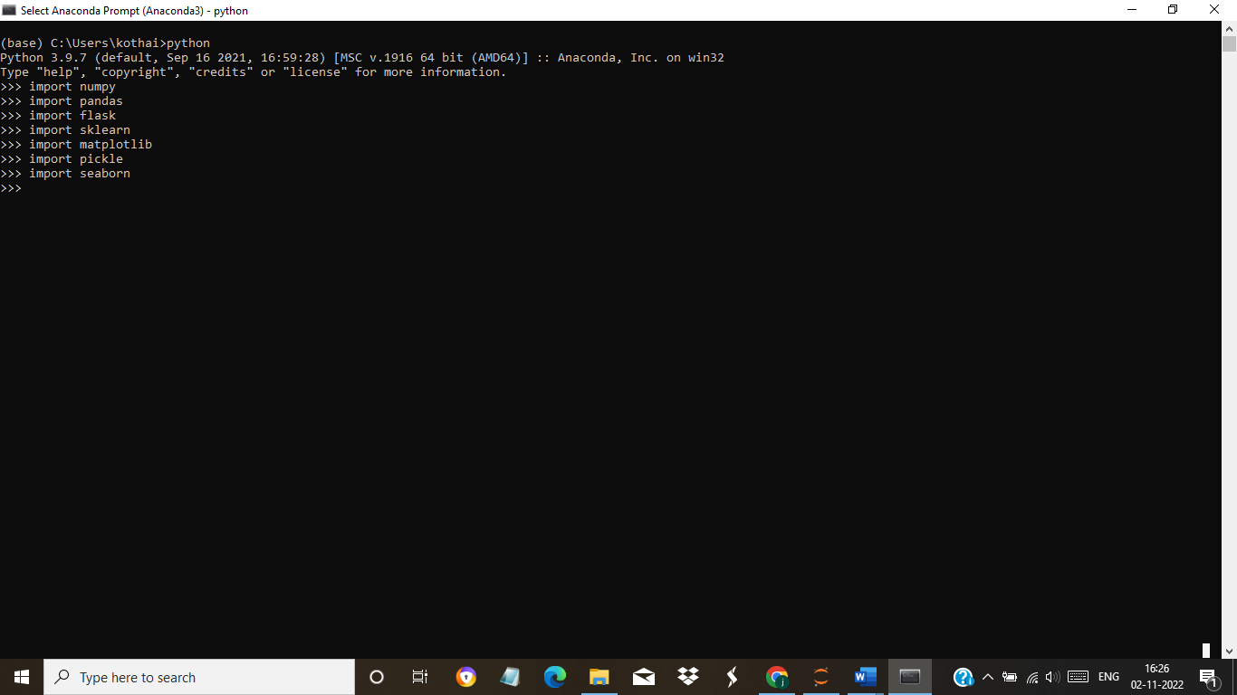

Python packages

Therefore, Required software, concepts, and packages are download